Lab 12 – PostgreSQL

Student’s name: Abidemi Alade

Tuesday 4/29/2025 (introduction)

Class example:

Lab exercise: Manually create a database, table, and columns.

* Database: demoDB
* Tables: Courses, tuition (both need a primary key)
  + Courses table will have 3 columns: course_code (2 characters), semester (character varying), schedule (text)
    - Create two courses data entries
    - A screenshot of a computer

      AI-generated content may be incorrect.
  + Tuition table will have 3 columns: id (primary key), pt_credit_per(numberical), ft_price(numberical)
    - Create one data entry for local student
    - Create one data entry for international students
    - A screenshot of a computer

      AI-generated content may be incorrect.

Thursday 5/1/2025

LAB12B

1. Create the Table

Create a table named books with the following structure:

• id – SERIAL PRIMARY KEY

• title – VARCHAR(100) NOT NULL

• author – VARCHAR(100) NOT NULL

• year_published – INT

2. Insert Records

Insert the following records into the books table:

title author year_published

The Great Gatsby F. Scott Fitzgerald 1925

Animal Farm George Orwell 1945

To Kill a Mockingbird Harper Lee 1960

Brave New World Aldous Huxley 1932

3. Read Data

Write SQL queries to:

• Select all books.

• Select books where the author is 'George Orwell'.

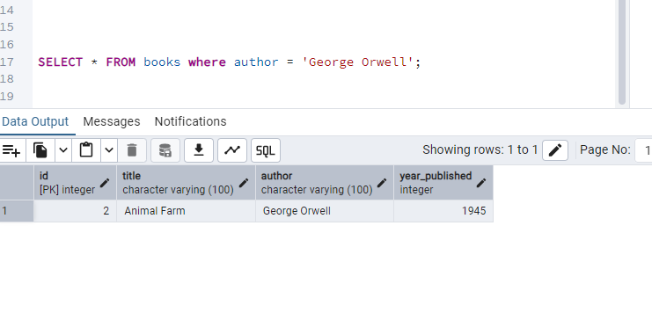

4. Update Data

Update the year_published of Brave New World to 1931.

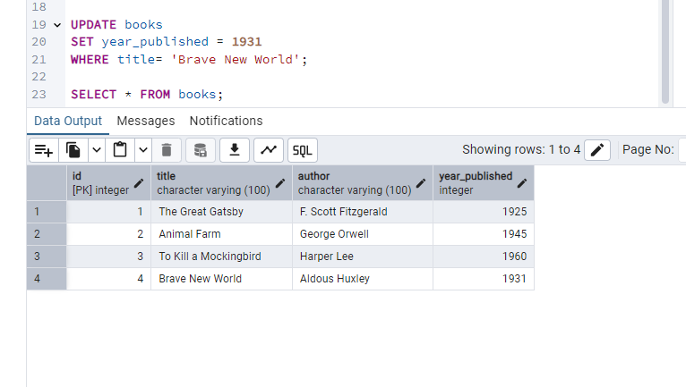

5. Delete Data

Delete the record for To Kill a Mockingbird.

6. View Final Table

Select all records from the books table to verify your changes.

Bonus Challenge (Optional)

• Add a new column genre to the books table.

• Update the genre for each book.

• Select all books grouped by genre.

